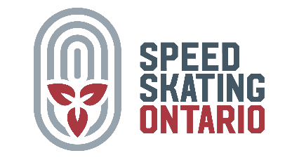

Regional Meet

Hosted by (name of club)

Date:
Location:
Skater Eligibility: | Skaters aged 4-9 with a Speed Skating Ontario Club Membership.
Health Measures: | Please stay home if you are feeling unwell.
Sanctioned By: | Speed Skating Ontario
Entry Fee: | $ per person. No refunds after the close of registration.
Entry Deadline: | (date)
Entries via: | All skaters must register (suggestions- link to a google form or through their club).
Check In: | Coaches should notify the host club if any skaters are absent before racing begins.
Volunteers: | Please let us know if you are interested in volunteering by
Coaches: Coaches will meet prior to the start of racing
Officials: Officials will meet prior to the startof racing.
Meet Contact:
Equipment: | Please see D3-100 in the SSC Red Book.

